TSC - 2018-19 POST POOL MOBILITY 7-8 MINS

ROTOR CUFF HOLD 10 SEC EACH ARM
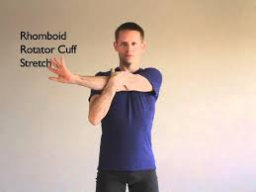

TRI-CEP HOLD 10 SEC EACH ARM
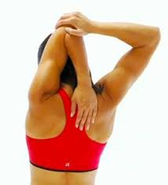
THORASIC STRETCH 5 SLOW EACH ARM
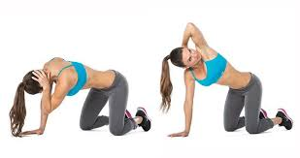
HIP FLEXOR STRETCH HOLD 10 SEC EACH LEG
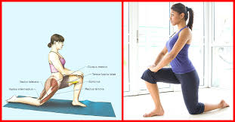

HAMSTRINGS STRETCH HOLD 10 SEC EACH LEG

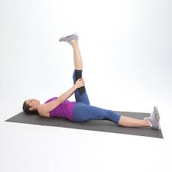

COMBO QUAD -HIP FLEXOR STRETCH HOLD 10 SEC EACH LEG

ADUCTORS GRADUALLY APPLY DOWNWOOD PRESURE TO EACH KNEE
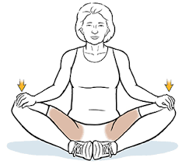

LOWER LUMBAR HIP TWIST THROASIC BRING KNEES OVER 4 SLOW EACH SIDE
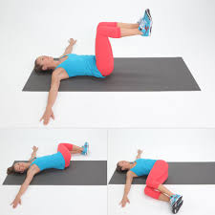

LATISSIMUS STRETCH PRESS HEAD DOWN BETWEEN ARMS HOLD 10 SEC
