Personal kit must be clearly labelled/marked with your name. It is important that you swimmers have their own equipment to ensure that you do not have to rely on borrowing kit from other swimmers. Please bring your kit bag to ALL sessions.
Kit Item | Photo of Example Kit | Kit Required per Squad
Mesh kit bag (any brand) | 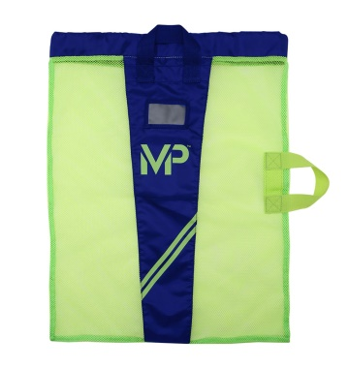 | NAR  COUNTY  JCD  TOP CLUB  PLATINUM  DIAMOND  GOLD  SILVER  BRONZE
Kickboard – any brand | 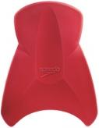 | NAR  COUNTY  TOP CLUB  JUNIOR COUNTY DEV  PLATINUM  DIAMOND  GOLD  SILVER  BRONZE
Water Bottle: any brand. Remember to wash out each night to avoid bacteria build-up or use disposable bottles | 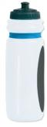 | NAR  COUNTY  TOP CLUB  JUNIOR COUNTY DEV  PLATINUM  DIAMOND  GOLD  SILVER  BRONZE
Training Fins – any brand but must be SHORT fins | 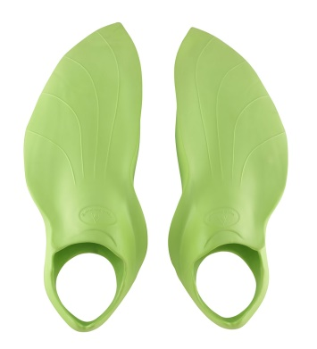 | NAR  COUNTY  TOP CLUB  JUNIOR COUNTY DEV  PLATINUM  DIAMOND  GOLD  SILVER
Pull-buoy – any brand | 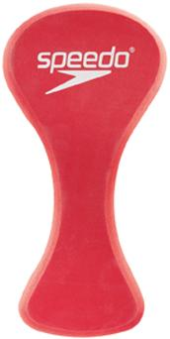 | NAR  NAR  COUNTY  TOP CLUB  JUNIOR COUNTY DEV  PLATINUM  DIAMOND  GOLD
Training hand paddles – any brand but MUST have vents and fit your hand properly. Vents and palm risers enhance the swimmers feel for the water. Most hand paddles come in 3 sizes. These are Michael Phelps branded paddles but any brand is fine. | 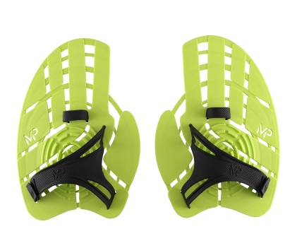 | NAR  COUNTY  TOP CLUB
Front-loading snorkel – any brand | 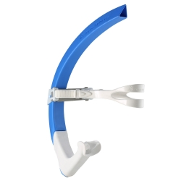 | NAR  COUNTY  TOP CLUB  JUNIOR COUNTY DEV
Finis Pull rubber band | 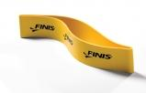 | NAR  COUNTY  TOP CLUB
Optional: Rollers for trigger point release, knotty fibres – any brand | 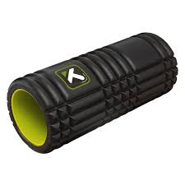 |  | NAR  COUNTY
Optional Finis Pacer – optional training aid to help maintain constant stroke rate | 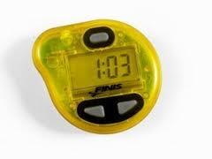 |  | NAR  COUNTY

Swim Training Kit Requirements for all Squads
 | NAR | COUNTY | TOP CLUB | JNR COUNTY DEV | PLATINIUM | DIAMOND | GOLD | SILVER | BRONZE
Required Items
Mesh/Net Kit Bag
Kickboard
Short Fins
Pull buoy
Snorkel
Finish Ankle Band
Paddles
Optional Items
Optional -Finis Pacer
Optional -Roller

Items can be purchased online at specialist online swimming stores or at amazon etc. Please do register with easyfundraising.com beforehand and click through to the site you are purchasing from to earn commission for your club, without costing you a single penny more.
We are unable to offer direct recommendations for particular stores as that is seen as an endorsement, however we would be happy to share with you where we purchase our own swimmers’ kit from if you ask us personally.

