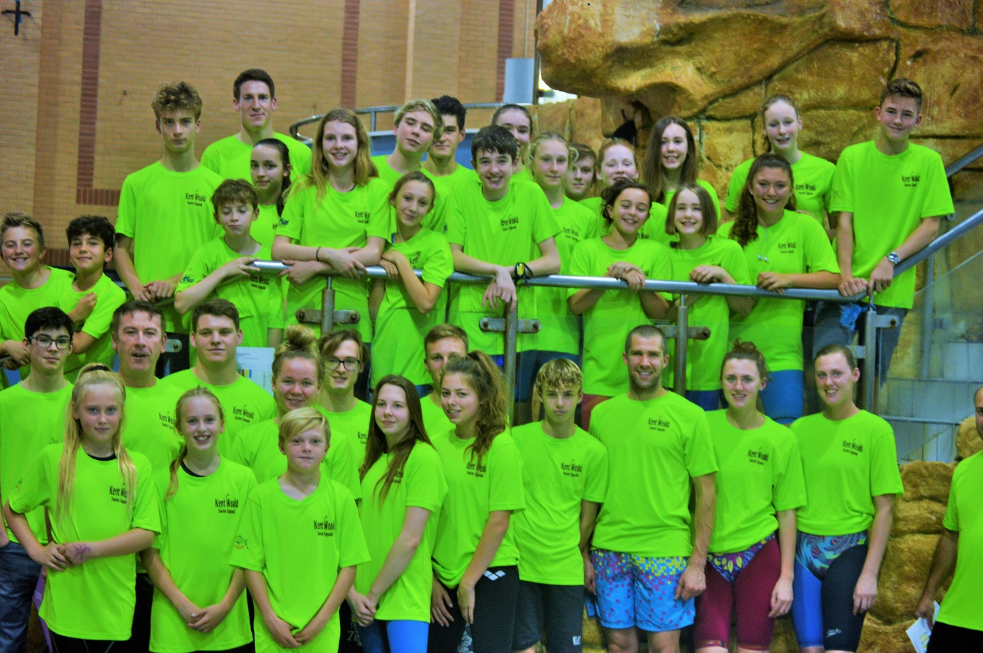
MEET REPORT National Arena Swimming League
RD 1 SATURDAY 14/10/17 AT THE TRIANGLE BURGESS HILL HOME OF MID SUSSEX MARLINS

It was a good omen, the sun was shining on the way down to Sussex on Saturday. I arrived in good time, walked into the foyer to a sea of luminous green and smiling faces, cI was not sure whether the smiles were due to the sartorial choice of shirts, a random green Mohawk wig or the anticipation of racing for the first time as Kent Weald. Maybe it was a mixture of all but whatever it was the atmosphere was electric. I thought if nothing else and things go sideways we could join the motorway crew of McAlpines on the way back and fill some pot holes on the road with the High Vis shirts. In the event, we ended up at that paragon of culinary rigour and well known Scottish restaurant Mc Donald’s just off the M25 Clacket lane, for some fast food that was very slow in the serving, but that was later and after the main event.

The warm up proceeded as all warm ups do, with a lot of people crammed in to a small space, which kind of resembled the opening day of the New Year’s Day sales at Harrods, and after the bunfight comically described as a warm up we were off with the ladies 200 IM with Caitlin Ebbage taking a creditable 2nd place to Hailsham. Next up was Brandon Harris picking up a third place with a tidy Pb.

Next came the first series of 8 relays, consisting of free and Medley teams from the boys and girls 9/11, the 13/u, the 15/u and the men’s and Ladies open age relays. Of the eight relays, Kent Weald took four second places and four third places. Amongst the relay swims there were split time improvements from Kayla Moerman, Kara Mitchel, Cicily Thomas-Green, Ruben Cowley-Antelo, Holly Geake, William Fitzpatrick, Ollie Isaacs, Dan Brice, Charlie Curtis, Toby Henbest, Tilda Durrant, Amelie Thomas –Green, Noemie Thomson, Brandon Harris, Isaac Davis, Ellis Kottas, Sarah Brown, Jodie Mitchel, David Carr and Ollie Durrant. On Pb or just a couple of tenths off, were Maddie Holland, Tom Allen, Lois Duchesne, Erin Nisbet, Evan Norris, Charlie Brice and Phoebe Kirkby.

The next 32 races were individual races, of which 15 personal bests were achieved by Cicily, Brandon, Ollie Isaacs, Lois, Kayla, Evan, Dan, Elle, Josh Prendergast, Isaac, Caitlin and Noemie.

11 First places were gained by Joshua Prendergast, Erin Nisbet, Ollie Isaacs, Lois Duchesne (2), Brandon Harris (2), Dan Brice (2) and Caitlin Ebbage (2).

6 Second places were taken by Cicly, Kayla, Evan ,Joshua, Erin and Stew; whilst there were five third places by Sarah, Elle ,Tilda, Noemie and Leigha.

Kent consideration times were delivered by Cicily Thomas- Green, Sarah Brown, Evan Norris, Elle Nikhwai, Leigha Mitchel and Noemie Thomson.

Kent Auto times were served up by Josh Prendergast, Dan Brice, Caitlin Ebbage, Ollie Isaacs and Kayla Moerman.

There were also five tough to get Winter regional QTs won with three from Brandon, one each from Lois and Caitlin.

The last set of relays were the boys and girls 9/11, 13/u, 15/u and the Mens and Ladies open medley and free relays. This time teams swum the opposite way round from the first set of relays. Of these 8 relays, KWSS achieved six second places, a third place. With a first place from the boys 9/11 medley team consisting of Charlie Brice, Josh Prendergast and Evan Norris, with Ruben Cowley Antelo anchoring the team home.

The Ladies and Mens squadron were the last two events to be raced. Both were very exciting relays and the KWSS Mens and Ladies teams both romped to solid 2nd places.

The final points totals were:

Hailsham 290
KWSS 273
Beckenham B 218
Mid Sussex Marlins 199
Canterbury 168
White Oak 126
Dartford 113

Let me say it was and is an honour to be picked for this team and there was a lot of competition for places. Some tough calls had to be made but the best current swimmers from both clubs were selected and came together as one team. I and the coaching team from both clubs challenge those that just missed out on selection to step up in training over the next 4 weeks and compete for a place in the next round.

What started yesterday won’t change the world, but it will change the TSC and BSS world, but the question is what will the world look like after we have changed it. I am confident it will look much, much better. If we can’t make the world, or at least our little bit of it better what’s the point in all this right!! and its thanks to all of your support the members from both clubs and two very passionate chairman and the committees of both clubs that we can now call our team KENT WEALD.

KWSS Coaching Team

