Kent County Swimming Championships continue with PBs galore and 6 more golds and 2 bronzes for Tonbridge swimmers
Josh Prendergast WINS 4 more GOLDS!
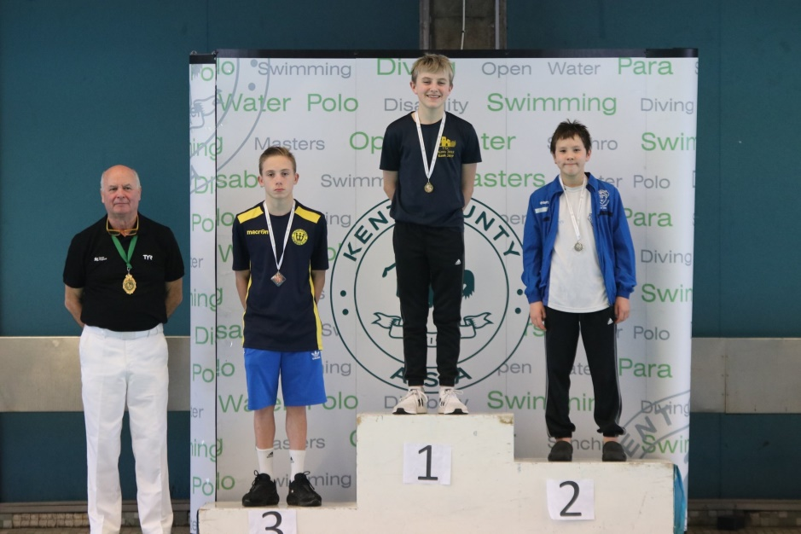

Josh Prendergast continued his awesome form and won 4 (out of 4) Gold medals on offer in Weekend no. 2. Winning the 400m Freestyle with a 29 second LC pb and 12 seconds inside the Auto SE Regional QT. This swim ranks Josh 4th in SER and 10th in GB.
Josh followed that up later with his 2nd gold of the day in the 13 years 400 IM. Another huge 1 minute 26 second LC pb. This awesome swim saw him rise to 7th in the GB rankings.
Returning on Sunday to continue his good form, Josh stole the show with another Gold medal in the Boys 200m IM with an 18 second pb.
Josh’s final swim of the weekend was the 800m Freestyle, a new Olympic event. Keen to put his mark on it from the very first 50 meter turn, Josh led his competitors, getting out in front. He never let go with a very consistent spilt time of 37 for each 50. His swim was a an 11 second pb on his converted short course time – a very difficult task to achieve. This swim finished his golden weekend with his 6th Gold medal of the championships.
Ollie Isaacs, swimming in the very competitive Boys 15 years age group swam a great race and was rewarded with a 2.5 second LC pb and 10th place.
TSC had 4 girls in action on Saturday. Holly Geake, swam in the 400m Freestyle for the first time in a Long Course pool gained 12th place. She followed this up on Sunday with a lovely 200 IM swim to gain 10th place in the 14 Years Girls event and smash her previous LC pb by 19 seconds.
Noemie Thomson, also debuting in the LC 400m Freestyle event, swam a well-paced race to finish 10th in the Girls 16 years event.
Erin Nisbet had a hectic weekend swimming in 3 events. First up was the gruelling 400 IM. Erin stormed to a new 17 second LC pb, gained an automatic SER QT by 6 seconds and won the bronze medal in the Girls 14 Years age group. She followed this up in the next session with a stonking 21 second LC pb and a SER Consideration time to finish in 8th place. Returning on Sunday for the 200m IM, Erin continued her rich vein of form with a 4 second LC pb and just missed the podium with a 4th place and gained valuable extra points for the club.
Caitlin Ebbage was ready to start her 2019 Kents campaign having missed the 1st weekend of the Kents due to competing in Flanders Belgium. In Belgium she spent an intense and gruelling 5 days training and competing last week against the likes of Katinka Hosszu (the Olympic and world record holder of multiple events and Silver medallist at Rio).
Caitlin won Gold in the Girls 14 Years 400 IM with a 3 second pb and won by a 12 second margin. Next up was the 400m Freestyle and she picked up the bronze medal, a small pb and SER Auto time.
On Sunday Caitlin won gold in one of her favourite events, the Girls 14 years 2OOIM with a small pb. Her final event of the weekend was the Girls 1500m freestyle (also a new Olympic event). Showing signs of tiredness from the previous weekends’ exploits in Flanders, it was suggested that Caitlin withdraw from the event to rest. Caitlin, in a courageous decision said she didn’t want to withdraw and opted to swim it and swam to 4th place and earnt the club good points.
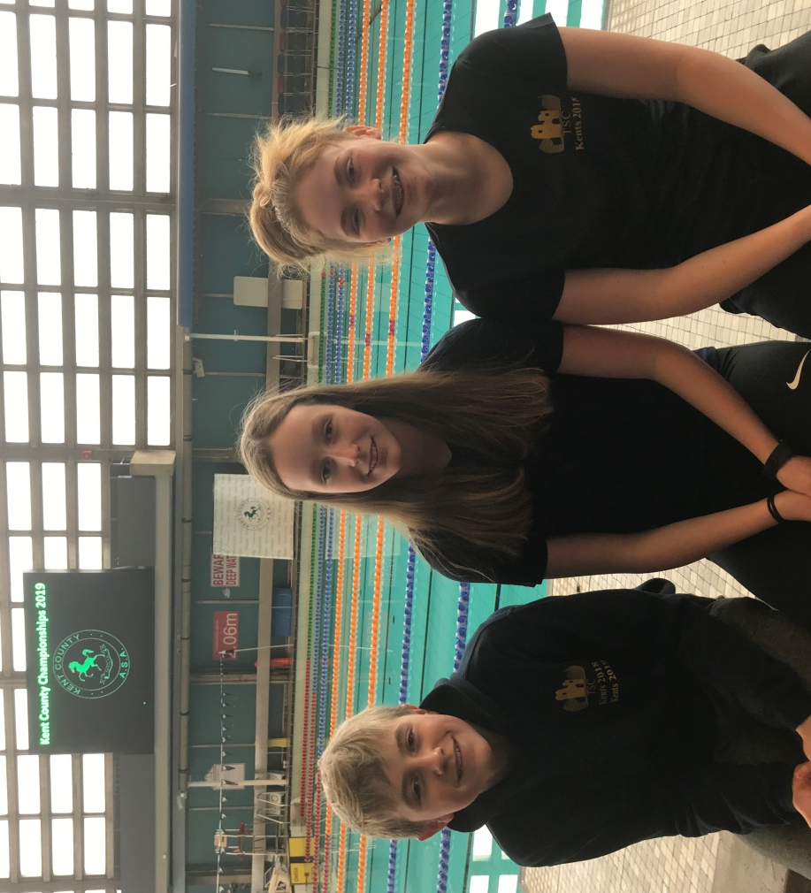
We are now half way through the championships and with plenty of signature events to come from TSC swimmers over the next two weekends we look forward to an exciting ride. Next weekend sees the Boys swim the 100m and 200m Breaststroke and Butterfly events, whilst the girls take on the Freestyle and Backstroke events.

Last weekend’s medallists: Josh, Caitlin and Erin

Tonbridge are currently 6th place in the overall Club’s medal table
9 GOLD 1 SILVER 3 BRONZE

Weekend 2

Kent County Championships
Saturday 26 & Sunday 27 January 2019 at
Crystal Palace (50m pool)

400m Individual Medley
Caitlin Ebbage (14) 5.18.20 1st PB/CR/SER Auto
Erin Nisbet (14) 5.35.58 3rd PB/SER Auto
Josh Prendergast (13) 5.23.11 1st PB/CR/SER Auto

400m Freestyle
Caitlin Ebbage (14) 4.52.92 3rd PB/CR/
Erin Nisbet (14) 4.58.94 8th PB
Holly Geake (14) 5.06.96 12th PB
Josh Prendergast (13) 4.47.15 1st PB/CR/SER Auto
Noemie Thomson (16) 5.02.04 10th PB/CR

200m Individual Medley
Caitlin Ebbage (14) 2.29.02 1st PB/CR/SER Auto
Erin Nisbet (14) 2.39.81 4th PB/SER Consideration
Holly Geake (14) 2.44.26 10th PB
Josh Prendergast (13) 2.30.05 1st PB/CR/SER Auto
Ollie Isaacs (15) 2.27.65 10th PB/CR

800m Freestyle
Josh Prendergast (13) 9.46.51 1st PB/CR/SER Consideration

1500m Freestyle
Caitlin Ebbage (14) 19.05.48 4th PB/CR/SER Consideration

