Sevenoaks Sprints Trophy Gala Report

On Saturday 7th October, Tonbridge Swimming Club took 20 swimmers to Sevenoaks to compete in the annual Sprints Trophy gala.

The opposition was provided by Sutton Atlantis, Chislehurst Millenium, Edenbridge Piranhas, Beacon SC and hosts Sevenoaks,

This was an excellent gala to perfect our speed, as the individual races were all 50m apart from the youngest age group (25m sprints) and all the relays were 4x25m splash and dashes. This gala also had mixed relays with each relay team being made up of two boys and two girls. With the boys and girls swimming in any order this made for some exciting races with the lead often changing on each length.

This was one of the best team efforts of recent months and with vociferous support from poolside and the gallery swimmers achieved 18 personal best times and no DQs. (Credit to the relay take over team of Gary and Rob in making sure no one left the wall early)

***SPOILER ALERT***

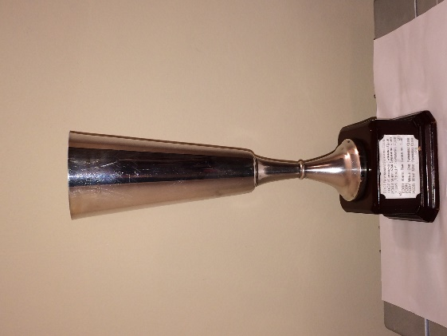
Tonbridge SC won the trophy!!!

Congratulations to all the swimmers as TSC bring home some silverware.

The final pointscores were:
1st Tonbridge 184.5;
2nd Beacon SC 166;
3rd Edenbridge Piranhas 160.5;
4th Sevenoaks 138.5;
5th Chislehurst 118.5;
6th Sutton Atlantis 78

We came 1st or 2nd in over half of the events and started the gala by winning 4 out of the first 5 events, as well as winning 5 of the last 6 events, to win by over 18 points.

1st place swims
Mixed relays – 10/u medley and Free; 14/u medley; 12/u medley; 8x25m squadron
Individuals – Grace MacAuley, Ruben Cowley-Antelo, Amelie Thomas-Green x2, Charlie Brice, Erin Nisbet, Sarah Brown, Oscar Thatcher, Noemie Thomson, Toby Henbest, Charlie Curtis.

2nd Place swims
Mixed Relays – Open medley; 14/u Free
Individuals – Holly Geake x2; Emily Geake; Harry Bevan; Sarah Brown

Congratulations to the following who all set new PBs:

25m
Back – Joshua Prendergast; Dan Brice; Emily Geake
Breaststroke – Riley Webster
Free – Oscar Thatcher; Noa Bossard; Riley Webster

50m
Back – Holly Geake; Joshua Prendergast
Breaststroke – Harry Bevan; Noemie Thomson; Charlie Curtis
Fly – Erin Nisbet; Toby Henbest; Oscar Thatcher
Free – Joshua Prendergast; Emily Sellors; Mia Devey

Congratulations to all the swimmers and a huge thank you to all our poolside helpers and officials (Lucy, Joy, Gary, Rob and Mark) and for all the families and friends cheering on from the gallery.

Bring on next year when we can defend our title!!

