3 X 30 MINS NON CONSEC WORKOUTS FOR FREE STYLE & BUTTERFLY /U/W
1.ARMS/CHEST /6 MINS
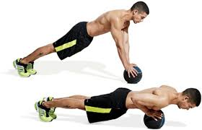
Wide grip press-ups Close grip press up with med ball
PRIMARY:TRICEPS BRAC/PEC MAJOR PRIMARY :PEC MAJ/TRI BRAC
SEC : ANTERIOR DELT SEC: PEC MINOR/ANT DELTOID
3 SETS OF 50 PRESSUPS ALTERNATE ODDS SETS WIDE GRIP/ EVEN SETS CLOSE GRIP

2. ABS /6 MINS
PHYSIO BALL CRUNCH
PRIMARY:RECTUS ABDOMINIS
SEC: EX –INT-OBLIQUE/TRANS ABS/RECTUS FEMORIS
6 SETS OF 45 SEC /15 SEC RI
3.LEGS/ 6 MINS
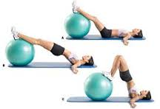
PRIMARY:GLUTES/BICEPS FEM
SEC : ERECTOR SPINAE
6 SETS OF 45 SEC /15 SEC RI

4. SHOULDERS/BACK 6 MIN
CHIN UPS WITH OVERHAND

PRIMARY:LATISSIMUS DORSI
SEC: LOWER TRAPS/RHOMBOID MAJ-MIN /BICEPS BRACHIALIS
2 SETS OF 4 /3 MIN RI

5.GENERAL WHOLE BODY / 6 MINS

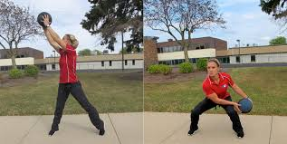
WITH LIGHT MED BALL
PRIMARY:REC FEM/GLUTES/ERECTOR SPINAE/EX –INT OBLIQUE/ANT-MID-POST DELT/TRI CEP
SEC: TRAPEZIUS/RHOMBOID MAJ-MIN
6 SETS OF 45 SEC/15 SEC RI ALT ODD SETS LEFT/EVEN SETS RIGHT

TOTAL 30 MINS PERFORM 3 TIMES A WEEK MON/WED/SAT ON NON CONSEC DAYS

